USB Allow Alert Instrument in android application

- download source code from <https://github.com/mik3y/usb-serial-for-android>

- create new project

- add usbSerialForAndroid folder as sub module

- config manifest.xml

<intent-filter>

<actionandroid:name="android.hardware.usb.action.USB_DEVICE_ATTACHED" /></intent-filter>

<meta-dataandroid:name="android.hardware.usb.action.USB_DEVICE_ATTACHED"android:resource="@xml/device_filter" />

- Copy device_filter.xml to your project's res/xml/ directory

- Connect USB host and get product id and vendor id from USB Device Info app

(<https://play.google.com/store/apps/details?id=aws.apps.usbDeviceEnumerator&hl=en>)

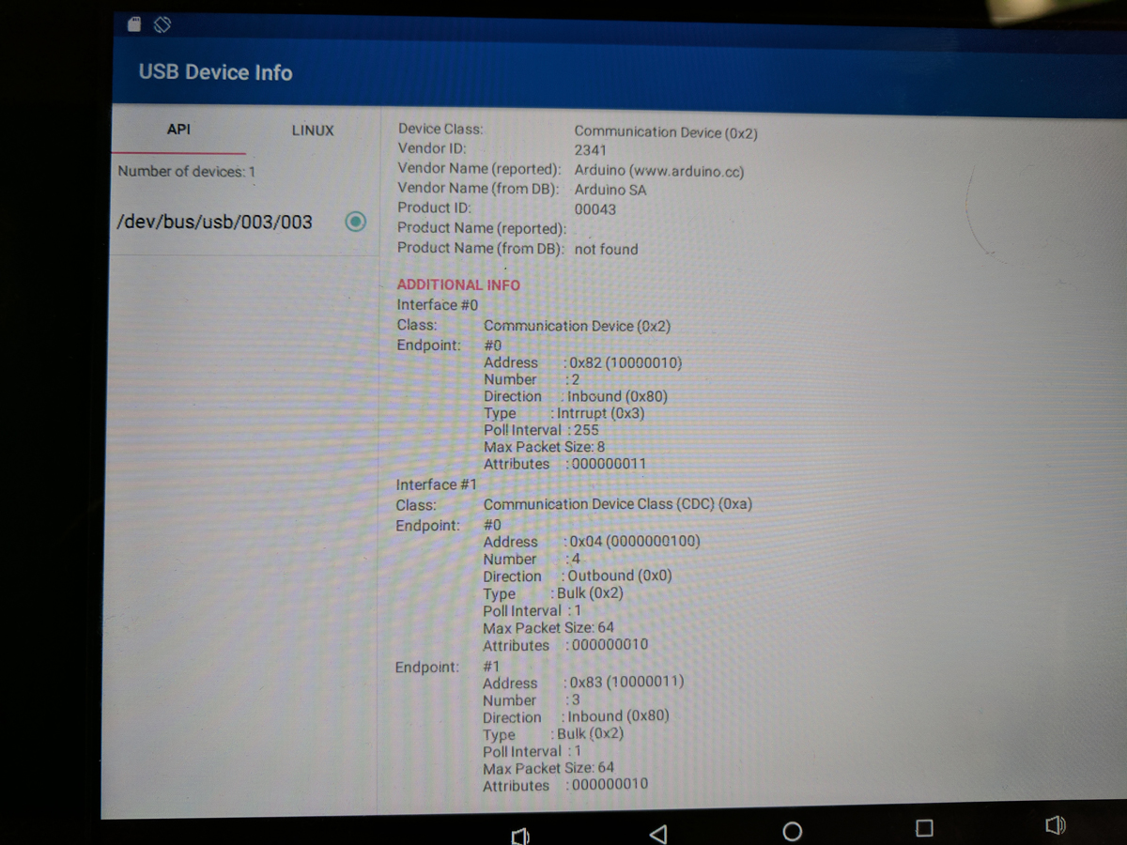

- add product id and vendor id to device_filter.xml

- build project and install apk

- connect to USB device , user must see USB Allow alert with ok and always allow.

If click always allow , it doesn’t appear again.